RAJALAKSHMI ENGINEERING COLLEGE

## RAJALAKSHMI NAGAR, THANDALAM – 602 105



|  |
| --- |
| **AI23331**  **FUNDAMENTALS OF MACHINE LEARNING LAB** |
| **Laboratory Observation Note Book** |

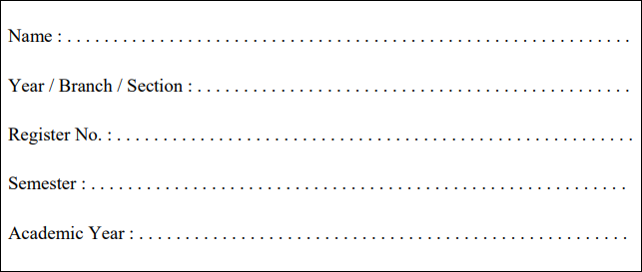

Maheshwaran.p

2nd Year/ AIML / A 231501510

3rd Semester

2024-2025

Ex No: 1 Date:

## A PYTHON PROGRAM TO IMPLEMENT UNIVARIATE, BIVARIATE AND

**MULTIVARIATE REGRESION**

# Aim:

To implement a python program using univariate, bivariate and multivariate regression features for a given iris dataset.

# Algorithm:

Step 1: Import necessary libraries:

* pandas for data manipulation, numpy for numerical operations, and matplotlib.pyplot for plotting.

Step 2: Read the dataset:

* Use the pandas `read_csv` function to read the dataset.
* Store the dataset in a variable (e.g., `data`).

Step 3: Prepare the data:

* Extract the independent variable(s) (X) and dependent variable (y) from the dataset.
* Reshape X and y to be 2D arrays if needed.

Step 4:Univariate Regression:

* For univariate regression, use only one independent variable.
* Fit a linear regression model to the data using numpy’s polyfit function or sklearn’s LinearRegression class.
* Make predictions using the model.
* Calculate the R-squared value to evaluate the model’s performance.

Step 5: Bivariate Regression:

* For bivariate regression, use two independent variables.
* Fit a linear regression model to the data using numpy’s `polyfit` function or sklearn’s `LinearRegression` class.
* Make predictions using the model.
* Calculate the R-squared value to evaluate the model’s performance.

Step 6: Multivariate Regression:

* For multivariate regression, use more than two independent variables.
* Fit a linear regression model to the data using sklearn’s `LinearRegression`

class.

* Make predictions using the model.
* Calculate the R-squared value to evaluate the model’s performance.

Step 7: Plot the results:

* For univariate regression, plot the original data points (X, y) as a scatter plot and the regression line as a line plot.
* For bivariate regression, plot the original data points (X1, X2, y) as a 3D scatter plot and the regression plane.
* For multivariate regression, plot the predicted values against the actual values.

Step 8: Display the results:

* Print the coefficients (slope) and intercept for each regression model.
* Print the R-squared value for each regression model.

Step 9: Complete the program:

* Combine all the steps into a Python program.
* Run the program to perform univariate, bivariate, and multivariate regression on the dataset.

# Code:

import pandas as pd

import matplotlib.pyplot as plt import seaborn as sns

import numpy as np df=pd.read_csv('/content/drive/MyDrive/Datasets/iris.csv') df.head(150)

df.shape df

df_Setosa=df.loc[df['species']=='setosa']

df_Virginica=df.loc[df['species']=='virginica'] df_Versicolor=df.loc[df['species']=='versicolor'] df_Setosa

#univariate for sepal width plt.scatter(df_Setosa['sepal_width'],np.zeros_like(df_Setosa['sepal_width']))

plt.scatter(df_Virginica['sepal_width'],np.zeros_like(df_Virginica['sepal_width']

))

plt.scatter(df_Versicolor['sepal_width'],np.zeros_like(df_Versicolor['sepal_widt h']))

plt.xlabel('sepal_width') plt.show()

#univariate for sepal length plt.scatter(df_Setosa['sepal_length'],np.zeros_like(df_Setosa['sepal_length']))

plt.scatter(df_Virginica['sepal_length'],np.zeros_like(df_Virginica['sepal_length ']))

plt.scatter(df_Versicolor['sepal_length'],np.zeros_like(df_Versicolor['sepal_len gth']))

plt.xlabel('sepal_length') plt.show()

#univariate for sepal width plt.scatter(df_Setosa['petal_width'],np.zeros_like(df_Setosa['petal_width']))

plt.scatter(df_Virginica['petal_width'],np.zeros_like(df_Virginica['petal_width']

))

plt.scatter(df_Versicolor['petal_width'],np.zeros_like(df_Versicolor['petal_widt h']))

plt.xlabel('petal_width') plt.show()

#univariate for sepal length plt.scatter(df_Setosa['petal_length'],np.zeros_like(df_Setosa['petal_length']))

plt.scatter(df_Virginica['petal_length'],np.zeros_like(df_Virginica['petal_length'

]))

plt.scatter(df_Versicolor['petal_length'],np.zeros_like(df_Versicolor['petal_leng th']))

plt.xlabel('petal_length') plt.show()

#bivariate sepal.width vs petal.width

sns.FacetGrid(df,hue='species',height=5).map(plt.scatter,"sepal_width","petal_ width").add_legend();

plt.show()

#bivariate sepal.length vs petal.length sns.FacetGrid(df,hue='species',height=5).map(plt.scatter,"sepal_length","petal

_length").add_legend(); plt.show()

#multivariate all the features sns.pairplot(df,hue='species',size=2)

# Output:

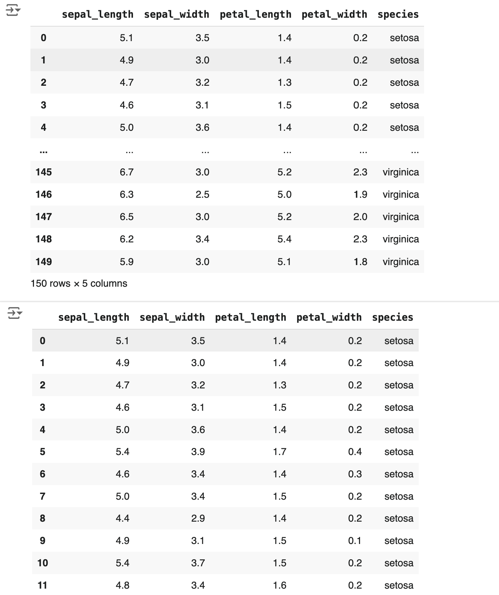

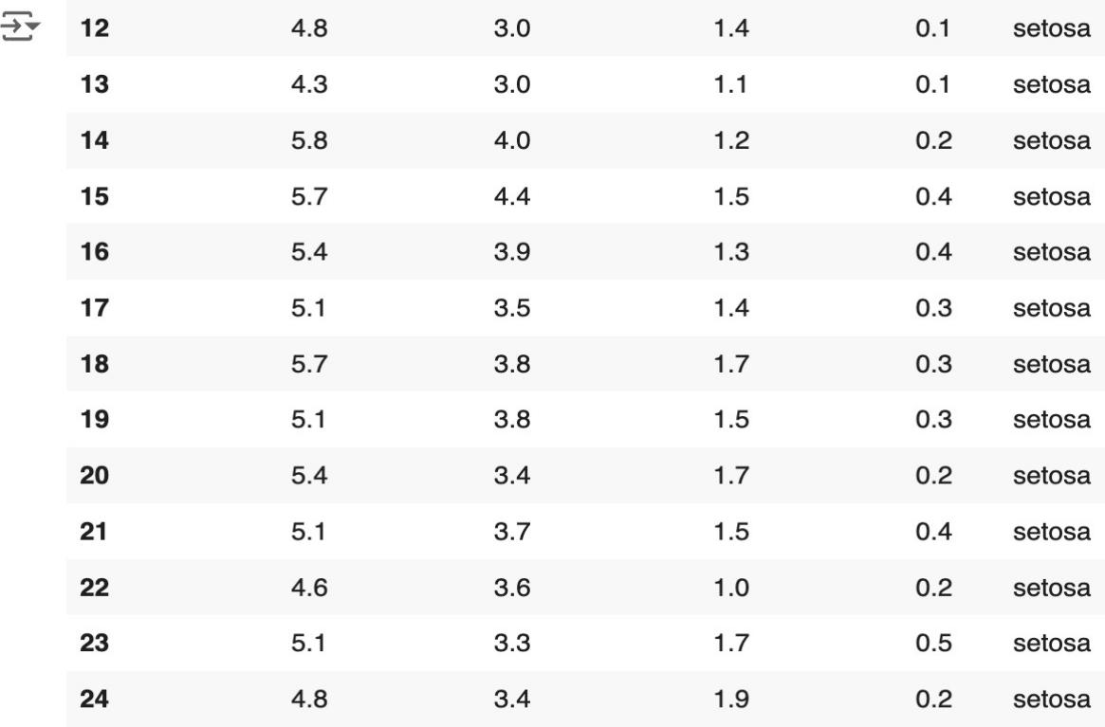

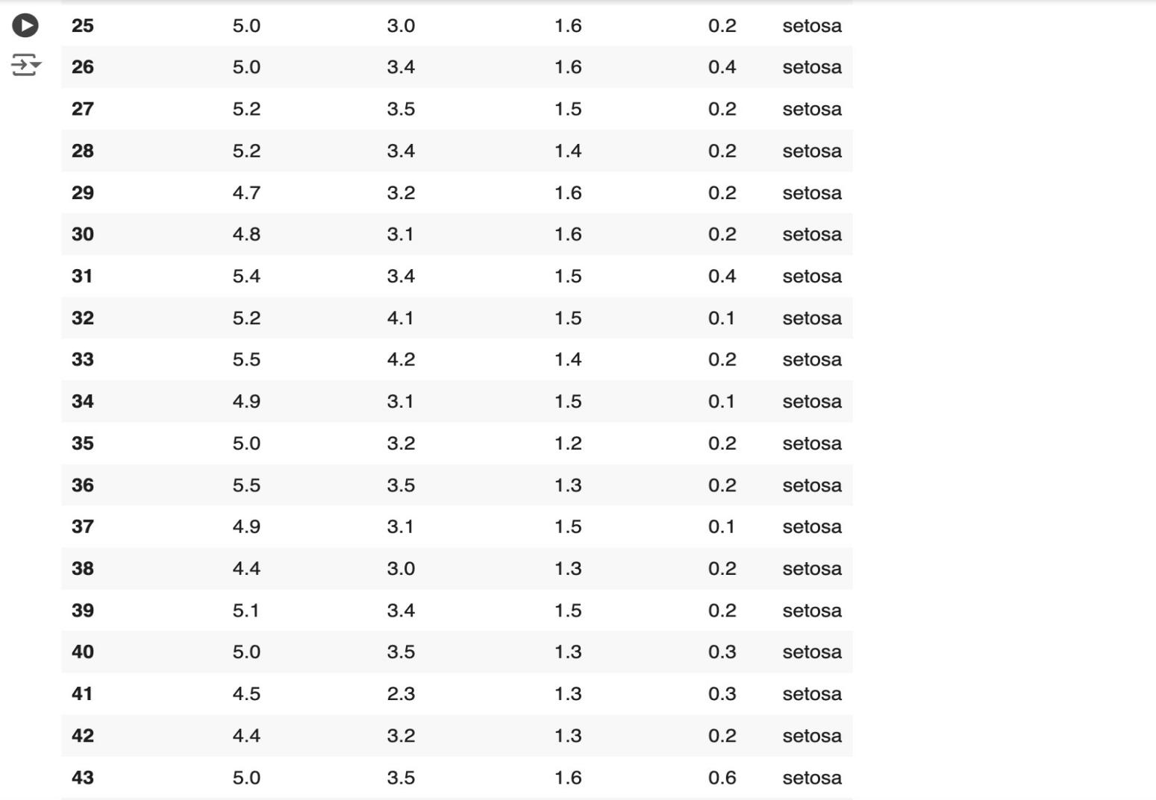

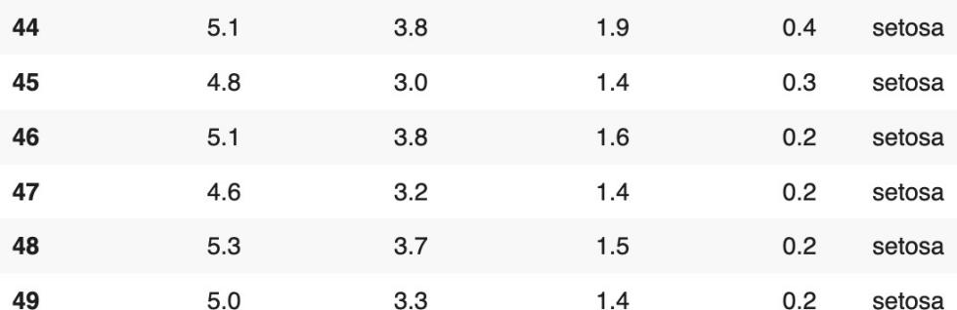

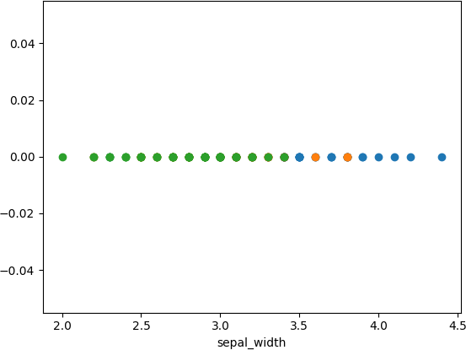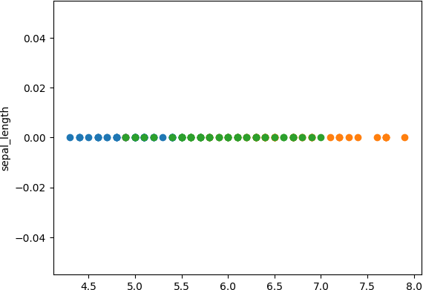

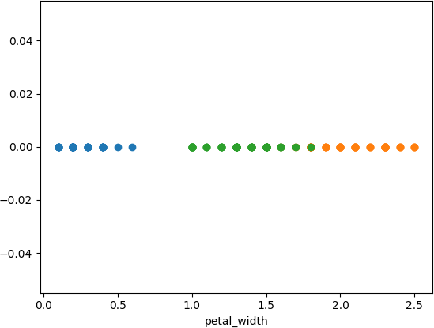

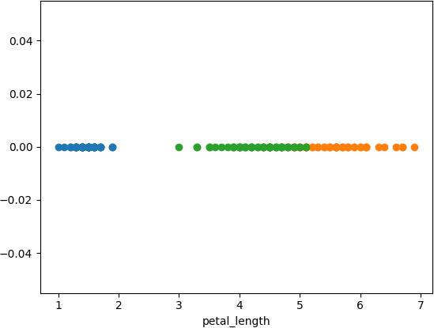

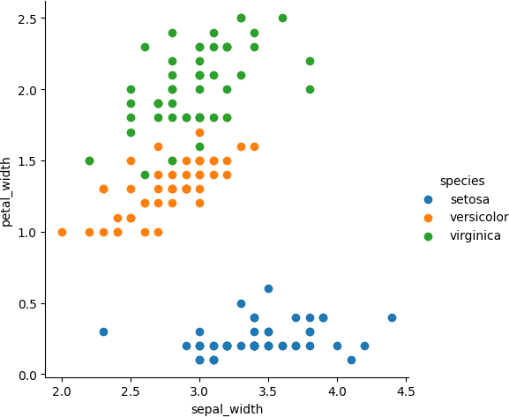

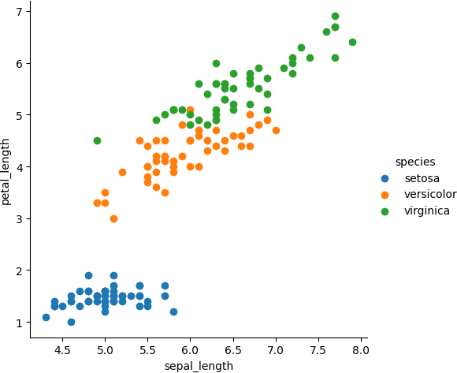

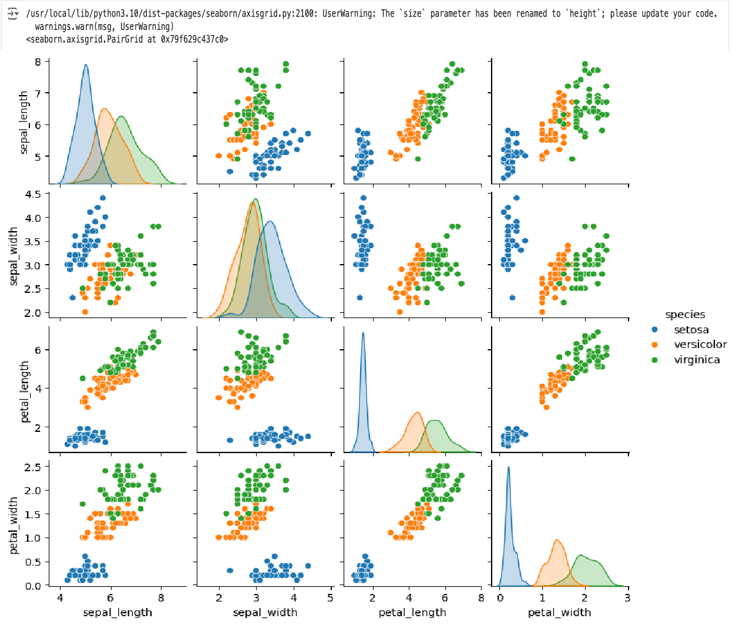

**Result:**

Thus, the python program to implement univariate, bivariate and multivariate has been successfully implemented and the results have been verified and analysed.

**Ex No: 2 Date:**

## A PYTHON PROGRAM TO IMPLEMENT SIMPLE LINEAR REGRESSION USING LEAST SQUARE METHOD

**Aim***:*

To implement a python program for constructing a simple linear regression using least square method.

# Algorithm:

Step 1: Import necessary libraries:

* pandas for data manipulation and matplotlib.pyplot for plotting.

Step 2: Read the dataset:

* Use the pandas `read_csv` function to read the dataset (e.g., headbrain.csv).
* Store the dataset in a variable (e.g., `data`).

Step 3: Prepare the data:

* Extract the independent variable (X) and dependent variable (y) from the dataset.
* Reshape X and y to be 2D arrays if needed.

Step 4: Calculate the mean:

* Calculate the mean of X and y.

Step 5: Calculate the coefficients:

* Calculate the slope (m) using the formula:

* Calculate the intercept (b) using the formula:

Step 6: Make predictions:

* Use the calculated slope and intercept to make predictions for each X value:



Step 7: Plot the regression line:

* Plot the original data points (X, y) as a scatter plot.
* Plot the regression line (X, predicted_y) as a line plot.

Step 8: Calculate the R-squared value:

* Calculate the total sum of squares (TSS) using the formula:
* Calculate the residual sum of squares (RSS) using the formula:



* Calculate the R-squared value using the formula:

Step 9: Display the results:

* Print the slope, intercept, and R-squared value.

Step 10: Complete the program:

* Combine all the steps into a Python program.
* Run the program to perform simple linear regression on the dataset.

## Code:

**Ex no: 3 Date:**

**A PYTHON PROGRAM TO IMPLEMENT LOGISTIC MODEL**

# Aim:

To implement python program for the logistic model using suv car dataset.

# Algorithm:

Step 1: Import Necessary Libraries:

* pandas for data manipulation
* sklearn.model_selection for train-test split
* sklearn.preprocessing for data preprocessing
* sklearn.linear_model for logistic regression
* matplotlib.pyplot for plotting

Step 2: Read the Dataset:

* Use pandas to read the suv_cars.csv dataset into a DataFrame.

Step 3: Preprocess the Data:

* Select the relevant columns for the analysis (e.g., 'Age', 'EstimatedSalary', 'Purchased').
* Encode categorical variables if necessary (e.g., using LabelEncoder or OneHotEncoder).
* Split the data into features (X) and target variable (y).

Step 4: Split the Data:

* Split the dataset into training and testing sets using train_test_split.

Step 5: Feature Scaling:

* Standardize the features using StandardScaler to ensure they have the same scale.

Step 6: Create and Train the Model:

* Create a logistic regression model using LogisticRegression from sklearn.linear_model.
* Train the model on the training data using the fit method.
  + Create a function named “Sigmoid ()” which will define the sigmoid

values using the

* + formula (1/1+e-z) and return the computed value.
  + Create a function named “initialize()” which will initialize the values with zeroes and assign the value to “weights” variable, initializes with ones and assigns the value to variable “x” and returns both “x” and “weights”.
  + Create a function named “fit” which will be used to plot the graph

according to the training data.

* + Create a predict function that will predict values according to the training model created using the fit function.
  + Invoke the standardize() function for “x-train” and “x-test”

Step 7: Make Predictions:

* Use the trained model to make predictions on the test data using the predict method.
  + Use the “predict()” function to predict the values of the testing data and assign the value to “y_pred” variable.
  + Use the “predict()” function to predict the values of the training data and assign the value to “y_trainn” variable.
  + Compute f1_score for both the training and testing data and assign

the values to “f1_score_tr” and “f1_score_te” respectively

Step 8: Evaluate the Model:

* Calculate the accuracy of the model on the test data using the score method.

(Accuracy = (tp+tn)/(tp+tn+fp+fn)).

* Generate a confusion matrix and classification report to further evaluate the model's performance.

Step 9: Visualize the Results:

* Plot the decision boundary of the logistic regression model (optional).

## Code:

import pandas as pd import numpy as np

from numpy import log,dot,exp,shape

from sklearn.metrics import confusion_matrix

data = pd.read_csv('/content/drive/MyDrive/suv_data.csv') print(data.head())

x = data.iloc[:, [2, 3]].values y = data.iloc[:, 4].values

from sklearn.model_selection import train_test_split

x_train, x_test, y_train, y_test=train_test_split(x,y,test_size=0.10, random_state=0)

from sklearn.preprocessing import StandardScaler

sc=StandardScaler() x_train=sc.fit_transform(x_train) x_test=sc.transform(x_test) print (x_train[0:10,:])

from sklearn.linear_model import LogisticRegression classifier=LogisticRegression(random_state=0) classifier.fit(x_train,y_train)

LogisticRegression (random_state=0) y_pred = classifier.predict(x_test) print(y_pred)

from sklearn.metrics import confusion_matrix cm = confusion_matrix(y_test, y_pred)

print ("Confusion Matrix : \n", cm)

from sklearn.metrics import accuracy_score

print ("Accuracy : ", accuracy_score(y_test, y_pred))

from sklearn.model_selection import train_test_split

x_train, x_test, y_train, y_test=train_test_split(x,y,test_size=0.10, random_state=0)

def Std(input_data):

mean0 = np.mean(input_data[:, 0]) sd0 = np.std(input_data[:, 0]) mean1 = np.mean(input_data[:, 1]) sd1 = np.std(input_data[:, 1])

return lambda x:((x[0]-mean0)/sd0, (x[1]-mean1)/sd1)

my_std = Std(x) my_std(x_train[0])

def standardize(X_tr):

for i in range(shape(X_tr)[1]):

X_tr[:,i] = (X_tr[:,i] - np.mean(X_tr[:,i]))/np.std(X_tr[:,i]) def F1_score(y,y_hat):

tp,tn,fp,fn = 0,0,0,0 for i in range(len(y)):

if y[i] == 1 and y_hat[i] == 1: tp += 1

elif y[i] == 1 and y_hat[i] == 0: fn += 1

elif y[i] == 0 and y_hat[i] == 1: fp += 1

elif y[i] == 0 and y_hat[i] == 0: tn += 1

precision = tp/(tp+fp) recall = tp/(tp+fn)

f1_score = 2*precision*recall/(precision+recall) return f1_score

class LogisticRegression: def sigmoid(self, z):

sig = 1 / (1 + exp(-z)) return sig

def initialize(self, X):

weights = np.zeros((shape(X)[1] + 1, 1)) X = np.c_[np.ones((shape(X)[0], 1)), X] return weights, X

def fit(self, X, y, alpha=0.001, iter=400): weights, X = self.initialize(X)

def cost(theta):

z = dot(X, theta)

cost0 = y.T.dot(log(self.sigmoid(z)))

cost1 = (1 - y).T.dot(log(1 - self.sigmoid(z))) cost = -((cost1 + cost0)) / len(y)

return cost

cost_list = np.zeros(iter,) for i in range(iter):

weights = weights - alpha * dot(X.T, self.sigmoid(dot(X, weights)) - np.reshape(y, (len(y), 1)))

cost_list[i] = cost(weights).item() self.weights = weights

return cost_list

def predict(self, X):

z = dot(self.initialize(X)[1], self.weights) lis = []

for i in self.sigmoid(z):

if i > 0.5: lis.append(1)

else:

lis.append(0) return lis

standardize(x_train) standardize(x_test)

obj1 = LogisticRegression() model = obj1.fit(x_train, y_train) y_pred = obj1.predict(x_test) y_trainn = obj1.predict(x_train)

f1_score_tr = F1_score(y_train, y_trainn) f1_score_te = F1_score(y_test, y_pred) print(f1_score_tr)

print(f1_score_te)

conf_mat = confusion_matrix(y_test, y_pred)

accuracy = (conf_mat[0, 0] + conf_mat[1, 1]) / sum(sum(conf_mat)) print("Accuracy is : ", accuracy)

# Output:

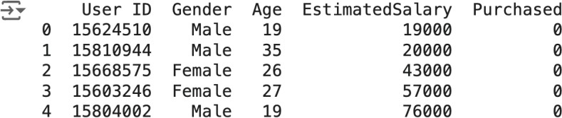

[[-1.05714987 0.53420426]

[ 0.2798728 -0.51764734]

[-1.05714987 0.41733186]

[-0.29313691 -1.45262654]

[ 0.47087604 1.23543867]

[-1.05714987 -0.34233874]

[-0.10213368 0.30045946]

[ 1.33039061 0.59264046]

[-1.15265148 -1.16044554]

[ 1.04388575 0.47576806]]

[0 0 0 0 0 0 0 1 0 1 0 0 0 0 0 0 0 0 1 0 0 1 0 1 0 1 0 0 0 0 0 0 1 0 0 0 0

0 0 1]

Confusion Matrix :

[[31 1]

[ 1 7]]

Accuracy : 0.95

(-1.017692393473028, 0.5361288690822568)

0.7583333333333334

0.823529411764706

Accuracy is : 0.925

# Result:

Thus, the python program to implement logistic model has been successfully implemented and the results have been verified and analyzed.

## Ex. No.: 4

**Date:**

**A PYTHON PROGRAM TO IMPLEMENT SINGLE LAYER PERCEPTRON**

# Aim:

To implement python program for the single layer perceptron.

## Algorithm:

Step 1: Import Necessary Libraries:

* Import numpy for numerical operations.

Step 2: Initialize the Perceptron:

* Define the number of input features (input_dim).
* Initialize weights (W) and bias (b) to zero or small random values.

Step 3: Define Activation Function:

* Choose an activation function (e.g., step function, sigmoid, or ReLU).
* User Defined function - sigmoid_func(x):
  + Compute 1/(1+np.exp(-x)) and return the value.
* User Defined function - der(x):
  + Compute the product of value of sigmoid_func(x) and (1 - sigmoid_func(x) ) and return the value.

Step 4; Define Training Data:

* Define input features (X) and corresponding target labels (y).

Step 5: Define Learning Rate and Number of Epochs:

* Choose a learning rate (alpha) and the number of training epochs.

Step 6: Training the Perceptron:

* For each epoch:
  + For each input sample in the training data:
  + Compute the weighted sum of inputs (z) as the dot product of input features and weights plus bias (z = np.dot(X[i], W) + b).
  + Apply the activation function to get the predicted output (y_pred).
  + Compute the error (error = y[i] - y_pred).
  + Update the weights and bias using the learning rate and error (W

+= alpha * error * X[i]; b += alpha * error).

Step 7: Prediction:

* Use the trained perceptron to predict the output for new input data.

Step 8: Evaluate the Model:

* Measure the performance of the model using metrics such as accuracy, precision, recall, etc.

## Code:

import numpy as np

from sklearn.metrics import accuracy_score, precision_score, recall_score, f1_score

input_dim=2 W=np.zeros(input_dim) b=0.0

def sigmoid_func(x):

return 1 / (1 + np.exp(-x)) def der(x):

sigmoid = sigmoid_func(x) return sigmoid * (1 - sigmoid)

np.random.seed(42) x = np.array([[150,8], [130,7],

[180,6],

[170,5]])

y = np.array([0,0,1,1])

alpha = 0.1

epochs = 10000

for epoch in range(epochs): for i in range(len(x)):

z = np.dot(x[i], W) + b y_pred = sigmoid_func(z) error = y[i] - y_pred

W += alpha * error * x[i] b += alpha * error

def predict(X):

z = np.dot(X, W) + b

return (sigmoid_func(z) > 0.5).astype(int) y_pred = predict(x)

accuracy = accuracy_score(y, y_pred) precision = precision_score(y, y_pred) recall = recall_score(y, y_pred)

F1_score = f1_score(y, y_pred)

print("Prediction:",y_pred) print("Accuracy:", accuracy) print("Precision:", precision) print("Recall:", recall) print("F1 Score:", F1_score)

## Output:

Prediction: [0 0 1 1]

Accuracy: 1.0

Precision: 1.0

Recall: 1.0

F1 Score: 1.0

## Result:

Thus, the python program to implement single layer perceptron has been successfully implemented and the results have been verified and analysed.

## Ex. No.: 5

**Date:**

**A PYTHON PROGRAM TO IMPLEMENT MULTI LAYER PERCEPTRON WITH BACK PROPOGATION**

# Aim:

To implement multilayer perceptron with back propagation using python.

# Algorithm:

Step 1: Import the Necessary Libraries

* Import pandas as pd.
* Import numpy as np.

Step 2: Read and Display the Dataset

* Use `pd.read_csv("banknotes.csv")` to read the dataset.
* Assign the result to a variable (e.g., `data`).
* Display the first ten rows using `data.head(10)`.

Step 3: Display Dataset Dimensions

* Use the `.shape` attribute on the dataset (e.g., `data.shape`).

Step 4: Display Descriptive Statistics

* Use the `.describe()` function on the dataset (e.g., `data.describe()`).

Step 5: Import Train-Test Split Module

* Import `train_test_split` from `sklearn.model_selection`.

Step 6: Split Dataset with 80-20 Ratio

* Assign the features to a variable (e.g., `X = data.drop(columns='target')`).
* Assign the target variable to another variable (e.g., `y = data['target']`).
* Use `train_test_split` to split the dataset into training and testing sets with a ratio of 0.2.
* Assign the results to `x_train`, `x_test`, `y_train`, and `y_test`.

Step 7: Import MLPClassifier Module

* Import `MLPClassifier` from `sklearn.neural_network`.

Step 8: Initialize MLPClassifier

* Create an instance of `MLPClassifier` with `max_iter=500` and

`activation='relu'`.

* Assign the instance to a variable (e.g., `clf`).

Step 9: Fit the Classifier

* Fit the model using `clf.fit(x_train, y_train)`.

Step 10: Make Predictions

* Use the `.predict()` function on `x_test` (e.g., `pred = clf.predict(x_test)`).
* Display the predictions.

Step 11: Import Metrics Modules

* Import `confusion_matrix` from `sklearn.metrics`.
* Import `classification_report` from `sklearn.metrics`.

Step 12: Display Confusion Matrix

* Use `confusion_matrix(y_test, pred)` to generate the confusion matrix.
* Display the confusion matrix.

Step 13: Display Classification Report

* Use `classification_report(y_test, pred)` to generate the classification report.
* Display the classification report.

Step 14: Repeat Steps 9-13 with Different Activation Functions

* Initialize `MLPClassifier` with `activation='logistic'`.
* Fit the model and make predictions.
* Display the confusion matrix and classification report.
* Repeat for `activation='tanh'`.
* Repeat for `activation='identity'`.

Step 15: Repeat Steps 7-14 with 70-30 Ratio

* Use `train_test_split` to split the dataset into training and testing sets with a ratio of 0.3.
* Assign the results to `x_train`, `x_test`, `y_train`, and `y_test`.
* Repeat Steps 7-14 with the new training and testing sets.

# Code:

import pandas as pd import numpy as np

from sklearn.model_selection import train_test_split from sklearn.neural_network import MLPClassifier

from sklearn.metrics import classification_report, confusion_matrix

bnotes = pd.read_csv('../content/drive/MyDrive/bank_note_data.csv') print(bnotes.head(10))

x = bnotes.drop('Class', axis=1) y = bnotes['Class'] print(x.head(2))

print(y.head(2))

def train_and_evaluate(activation, x_train, y_train, x_test, y_test): mlp = MLPClassifier(max_iter=500, activation=activation) mlp.fit(x_train, y_train)

pred = mlp.predict(x_test)

print(f"Predictions using activation function '{activation}':\n{pred}\n")

cm = confusion_matrix(y_test, pred) print(f"Confusion Matrix for '{activation}':\n{cm}\n")

report = classification_report(y_test, pred) print(f"Classification Report for '{activation}':\n{report}\n")

x_train, x_test, y_train, y_test = train_test_split(x, y, test_size=0.2)

for activation in ['relu', 'logistic', 'tanh', 'identity']: train_and_evaluate(activation, x_train, y_train, x_test, y_test)

x_train, x_test, y_train, y_test = train_test_split(x, y, test_size=0.3) for activation in ['relu', 'logistic', 'tanh', 'identity']:

train_and_evaluate(activation, x_train, y_train, x_test, y_test)

# Output:

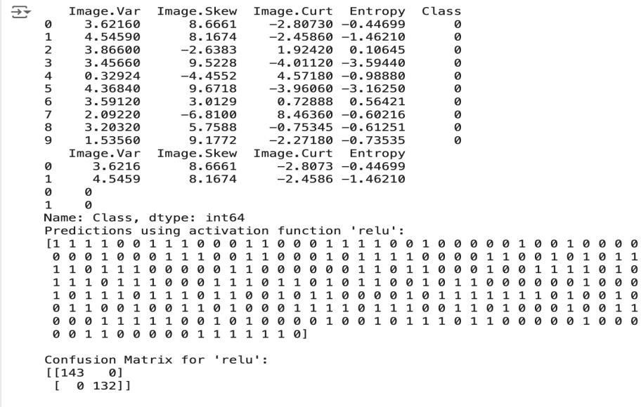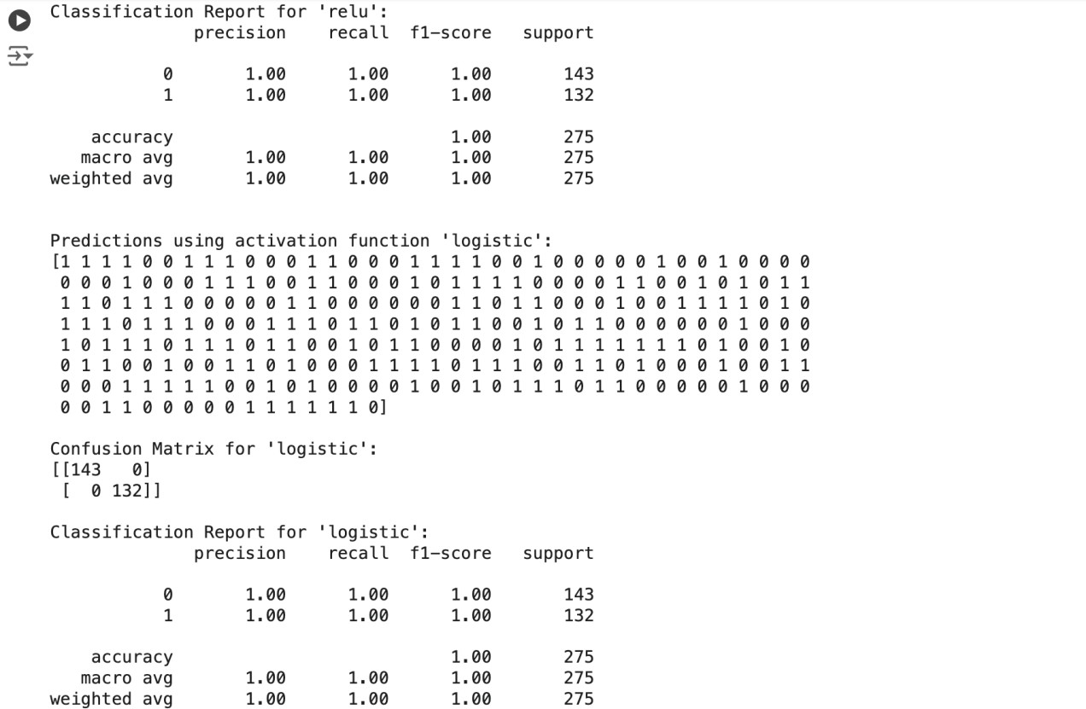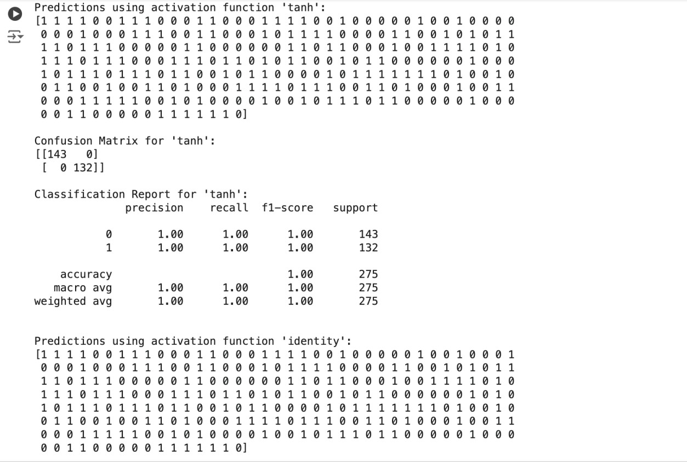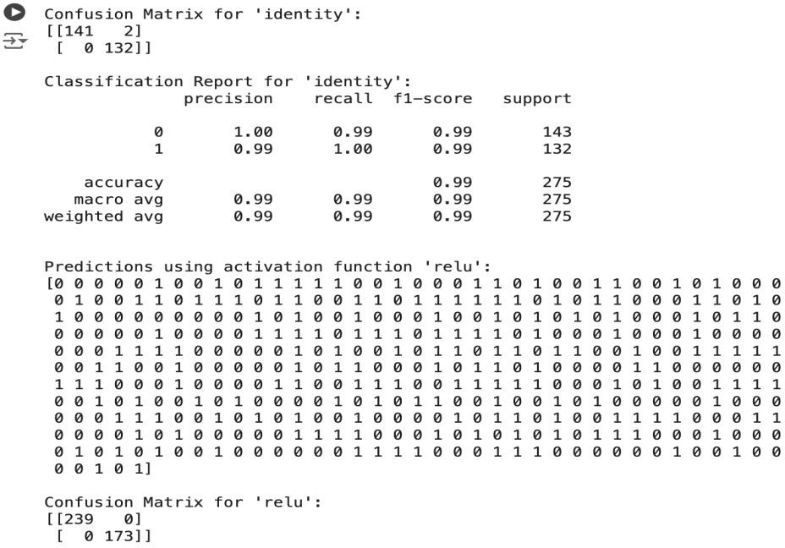

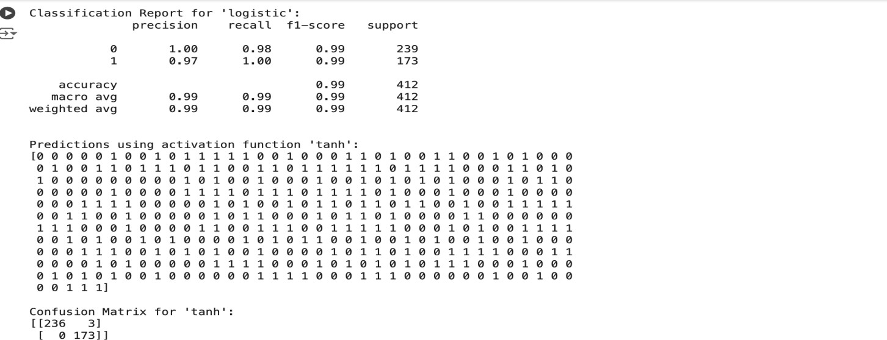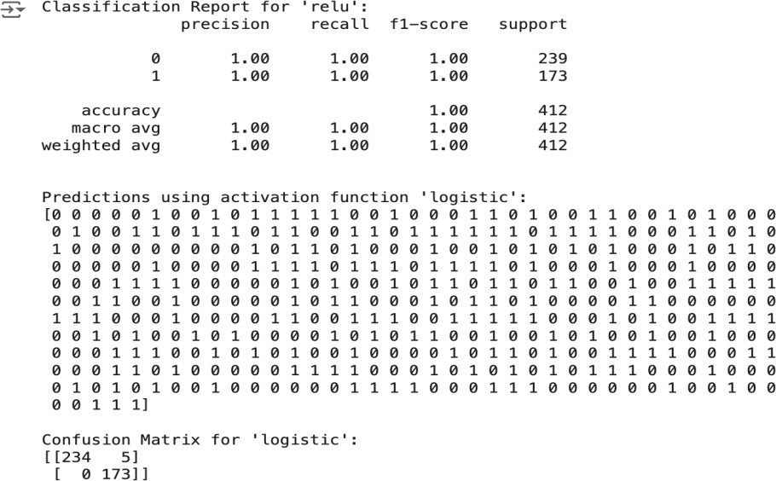

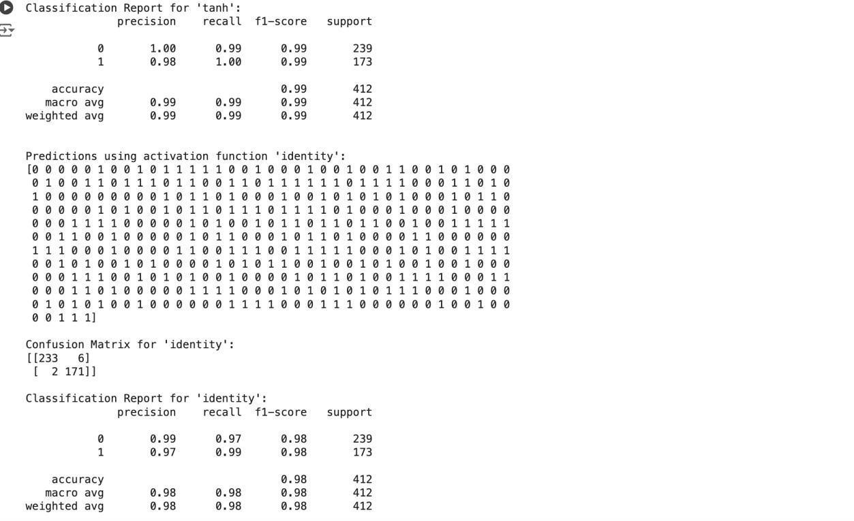

**Result:**

Thus, the python program to implement multi-layer perceptron has been successfully implemented and the results have been verified and analysed.

## Ex no: 6 Date:

**A PYTHON PROGRAM TO IMPLEMENT SVM CLASSIFIER MODEL**

**Aim:**

To implement a SVM classifier model using python and determine its accuracy.

**Algorithm:**

Step 1: Import Necessary Libraries

* Import numpy as np.
* Import pandas as pd.
* Import SVM from sklearn.
* Import matplotlib.pyplot as plt.
* Import seaborn as sns.
* Set the font_scale attribute to 1.2 in seaborn.

Step 2: Load and Display Dataset

* Read the dataset (muffins.csv) using `pd.read_csv()`.
* Display the first five instances using the `head()` function.

Step 3: Plot Initial Data

* Use the `sns.lmplot()` function.
* Set the x and y axes to "Sugar" and "Flour".
* Assign "recipes" to the data parameter.
* Assign "Type" to the hue parameter.
* Set the palette to "Set1".
* Set fit_reg to False.
* Set scatter_kws to {"s": 70}.
* Plot the graph.

Step 4: Prepare Data for SVM

* + Extract "Sugar" and "Butter" columns from the recipes dataset and assign to variable `sugar_butter`.
  + Create a new variable `type_label`.
  + For each value in the "Type" column, assign 0 if it is "Muffin" and 1 otherwise.

Step 5: Train SVM Model

* + Import the SVC module from the svm library.
  + Create an SVC model with kernel type set to linear.
  + Fit the model using `sugar_butter` and `type_label` as the parameters.

Step 6: Calculate Decision Boundary

* + Use the `model.coef_` function to get the coefficients of the linear model.
  + Assign the coefficients to a list named `w`.
  + Calculate the slope `a` as `w[0] / w[1]`.
  + Use `np.linspace()` to generate values from 5 to 30 and assign to variable `xx`.
  + Calculate the intercept using the first value of the model intercept and divide by `w[1]`.
  + Calculate the decision boundary line `y` as `a * xx - (model.intercept_[0] / w[1])`.

Step 7: Calculate Support Vector Boundaries

* + Assign the first support vector to variable `b`.
  + Calculate `yy_down` as `a * xx + (b[1] - a * b[0])`.
  + Assign the last support vector to variable `b`.
  + Calculate `yy_up` using the same method.

Step 8: Plot Decision Boundary

* + Use the `sns.lmplot()` function again with the same parameters as in Step 3.
  + Plot the decision boundary line `xx` and `yy`.

Step 9: Plot Support Vector Boundaries

* + Plot the decision boundary with `xx`, `yy_down`, and `'k--'`.
  + Plot the support vector boundaries with `xx`, `yy_up`, and `'k--'`.
  + Scatter plot the first and last support vectors.

Step 10: Import Additional Libraries

* + Import `confusion_matrix` from `sklearn.metrics`.
  + Import `classification_report` from `sklearn.metrics`.
  + Import `train_test_split` from `sklearn.model_selection`.

Step 11: Split Dataset

* + Assign `x_train`, `x_test`, `y_train`, and `y_test` using

`train_test_split`.

* + Set the test size to 0.2.

Step 12: Train New Model

* + Create a new SVC model named `model1`.
  + Fit the model using the training data (`x_train` and `y_train`).

Step 13: Make Predictions

* + Use the `predict()` function on `model1` with `x_test` as the parameter.
  + Assign the predictions to variable `pred`.

Step 14: Evaluate Model

* + Display the confusion matrix.
  + Display the classification report.

# Code:

import numpy as np import pandas as pd from sklearn import svm

import matplotlib.pyplot as plt import seaborn as sns

from sklearn.metrics import confusion_matrix, classification_report from sklearn.model_selection import train_test_split

sns.set(font_scale=1.2)

recipes = pd.read_csv('recipes_muffins_cupcakes.csv') print(recipes.head())

print(recipes.shape)

sns.lmplot(x='Sugar', y='Flour', data=recipes, hue='Type', palette='Set1', fit_reg=False, scatter_kws={"s": 70})

sugar_butter = recipes[['Sugar', 'Flour']].values type_label = np.where(recipes['Type'] == 'Muffin', 0, 1)

model = svm.SVC(kernel='linear') model.fit(sugar_butter, type_label)

w = model.coef_[0] a = -w[0] / w[1]

xx = np.linspace(5, 30)

yy = a * xx - (model.intercept_[0] / w[1])

b = model.support_vectors_[0] yy_down = a * xx + (b[1] - a * b[0])

b = model.support_vectors_[-1] yy_up = a * xx + (b[1] - a * b[0])

sns.lmplot(x='Sugar', y='Flour', data=recipes, hue='Type', palette='Set1', fit_reg=False, scatter_kws={"s": 70})

plt.plot(xx, yy, linewidth=2, color='black') plt.plot(xx, yy_down, 'k--')

plt.plot(xx, yy_up, 'k--')

plt.scatter(model.support_vectors_[:, 0], model.support_vectors_[:, 1], s=80, facecolors='none')

x_train, x_test, y_train, y_test = train_test_split(sugar_butter, type_label, test_size=0.2)

model1 = svm.SVC(kernel='linear') model1.fit(x_train, y_train)

pred = model1.predict(x_test)

print(pred) print(confusion_matrix(y_test, pred))

print(classification_report(y_test, pred, zero_division=1)) plt.show()

# Output:

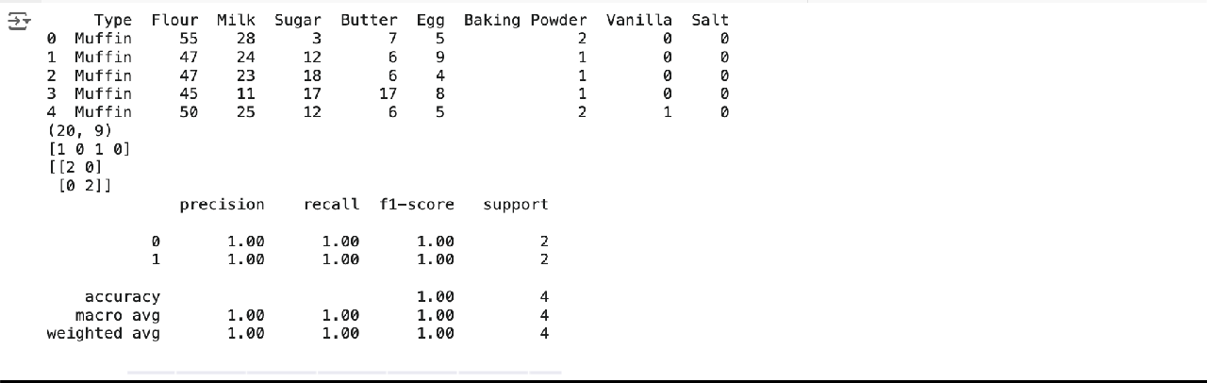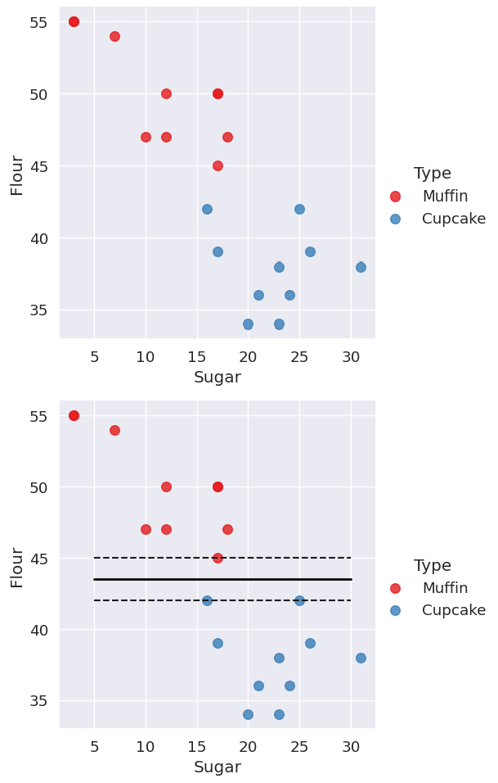

**Result:**

Thus, the python program to implement SVM classifier model has been successfully implemented and the results have been verified and analysed.